**온라인 프로필 만들기**

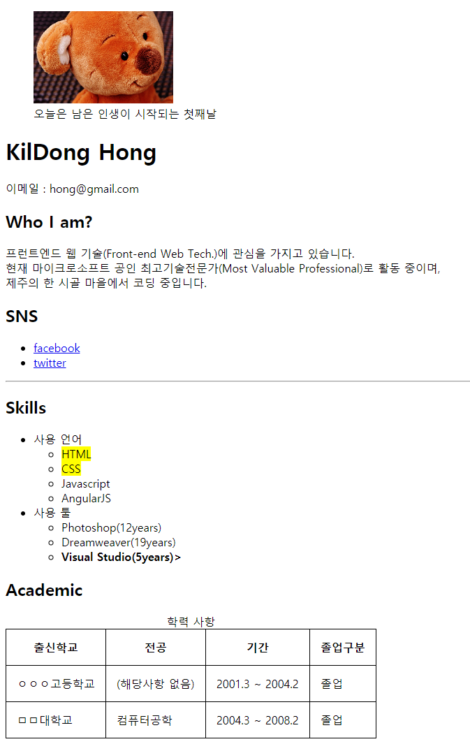

|  |
| --- |
| <!doctype html>  <html lang=*"ko"*>  <head>  <title>온라인 프로필</title>  <meta charset=*"utf-8"*>  <style>    </style>  </head>  <body>    </body>  </html> |